Quiz Application (Verilog + Flask): Documentation
A timed, 10-question multiple-choice quiz in the browser. A Flask server holds the questions, and the correct answers are checked by a Verilog design run in Icarus Verilog, so the answers never appear in the page's code. Screenshots of the running quiz are in section 9.

1. Overview
File | Role
app.py | Flask server. Holds the question list, serves the page, and runs the Verilog simulation to check each answer.
templates/index.html | Quiz page: layout and JavaScript for the timer, scoring, navigation and results screen.
static/style.css | Styling for the page.
quiz.v | Verilog source that knows the correct answers.
quiz.vvp | Compiled simulation file. It must be created manually before the quiz is used (see section 3).
The quiz.v file was not included with the files used for this document, so section 5 describes the Verilog interface as seen from app.py rather than its internal code.
Request flow
- The page loads with the 10 questions and their options embedded as JSON (no answers).
- The player clicks an option.
- The page sends POST /check with the question number and chosen option number.
- app.py runs vvp quiz.vvp +Q=<question> +A=<answer>.
- The Verilog testbench prints RESULT=1 (correct) or another result (wrong).
- app.py returns {"correct": true} or {"correct": false}, and the page updates the score and feedback.

2. Requirements
- Python 3 with Flask (pip install flask).
- Icarus Verilog, with iverilog and vvp available on the system PATH.
- A modern web browser.

3. Project structure and running
Flask looks for the page in templates and the stylesheet in static, and the page must be named index.html:
project/
├── app.py
├── quiz.v
├── quiz.vvp (compile before running)
├── templates/
│ └── index.html
└── static/
└── style.css
To run
- Compile the Verilog once, in the project folder, for example: iverilog -g2012 -o quiz.vvp quiz.v (add -s <testbench module> if quiz.v contains more than one top-level module).
- Run python app.py.
- Open http://127.0.0.1:5000/ in a browser.
Unlike a project that compiles on start-up, app.py does not compile anything itself. If quiz.vvp is missing, each answer check fails with quiz.vvp is missing. Compile quiz.v first.

4. Backend (app.py)

Question data
The questions list holds 10 dictionaries, each with a question string and an options list of four strings. The correct answers are not stored in Python.
# | Question | Options (A to D)
1 | Which language is used to structure a web page? | Python, HTML, Java, C++
2 | Which symbol is used for comments in Python? | //, #, <!-- -->, /* */
3 | Which data type stores True or False? | Integer, String, Boolean, Float
4 | Which keyword defines a function in Python? | function, define, func, def
5 | Which language is commonly used for styling web pages? | CSS, SQL, C, Verilog
6 | Which operator checks equality in Python? | ==, =, !=, >
7 | Which language describes digital hardware? | HTML, CSS, Verilog, SQL
8 | Which loop repeats while a condition is true? | if, switch, case, while
9 | Which HTML tag creates a hyperlink? | <a>, <p>, <h1>, <img>
10 | Which tool compiles and simulates Verilog? | Flask, Icarus Verilog, HTML, CSS

Routes
Route | Method | Purpose
/ | GET | Renders index.html, passing the questions to the page.
/check | POST | Checks one answer with the Verilog simulation.

POST /check
Request body (both numbers start at 0, so option A is 0 and option D is 3):
{ "question": 0, "answer": 1 }
Steps:
- Convert question and answer to integers. question must be from 0 to 9 and answer from 0 to 3.
- Confirm that quiz.vvp exists.
- Run vvp quiz.vvp +Q=<question> +A=<answer> in the project folder (5 second timeout).
- Reject the result if the process exited with an error.
- Collect every output line that starts with RESULT= and look at the last one. The answer is correct only if it is exactly RESULT=1.
- Return {"correct": true} or {"correct": false}.
The simulator's output and errors are also printed to the terminal for debugging.
Responses
Situation | Status | Body
Checked successfully | 200 | {"correct": true} or {"correct": false}
Question outside 0 to 9 | 400 | {"error": "Invalid question"}
Answer outside 0 to 3 | 400 | {"error": "Invalid answer"}
quiz.vvp missing | 500 | {"error": "quiz.vvp is missing. Compile quiz.v first."}
Simulation failed | 500 | {"error": "Verilog simulation failed: ..."}
No RESULT= line | 500 | {"error": "Verilog did not return a valid result."}
Any other exception (bad JSON, missing field, timeout) | 500 | {"error": "<message>"}

5. Verilog interface (quiz.v)
From how app.py uses it, the Verilog side works like this:
- It is compiled into quiz.vvp and run with two plusargs: +Q (question number, 0 to 9) and +A (chosen option, 0 to 3).
- It holds the correct option for each question, compares it with +A, and prints a line RESULT=1 when the answer is right.
- Any other RESULT= value (for example RESULT=0) counts as a wrong answer.
- If several RESULT= lines are printed, only the last one is used.

6. Front end (templates/index.html)

Layout
A title ("Quiz Application") with a subtitle, a progress line (Question N of 10) and score, a countdown timer, the question text, a container for the four option buttons, a feedback line, a Next Question button, and a hidden results panel with a Play Again button. The questions are inserted into the script with {{ questions | tojson }}.

State variables
Variable | Purpose
current | Index of the question being shown (0 to 9)
score | Number of correct answers so far
timeLeft | Seconds left on the 15 second timer
timer | Handle of the running setInterval
answered | True once the question has been answered or has timed out

Showing a question (showQuestion)
- Stop any running timer, reset answered and set the time to 15 seconds.
- Update the progress and score text, clear feedback, and disable the Next button.
- Show the question and create four buttons labelled A. ... to D. .... On the last question, the Next button reads See Results.
- Start a one-second timer. When it reaches 0 and the question is still unanswered, the feedback becomes Time's up!, the options are disabled, and Next is enabled.

Checking an answer (checkAnswer)
- Ignore the click if the question is already answered. Otherwise stop the timer, disable all options, and show Checking answer using Verilog....
- Send the question and chosen option to /check.
- If the answer is correct, add 1 to the score, colour the chosen option green, and show Correct answer!. If not, colour it red and show Incorrect answer!.
- If the request fails, show Error: <message> (the score is unchanged).
- In every case, enable the Next button.

Finishing and restarting
After the last question, showResult hides the quiz and shows Your score is N out of 10. The Play Again button calls restartQuiz, which resets current and score, shows the quiz again, and starts from question 1.

Styling (static/style.css)
- Centered white card (max width 600 px) on a purple gradient background.
- Option buttons have a light border that turns blue on hover; .correct is green and .wrong is red.
- The timer is orange and right-aligned; the Next and Play Again buttons are purple, with a grey disabled state.
- A [hidden] { display: none !important; } rule makes the hidden attribute work on the results panel and other elements.

7. Limitations and notes
- Answers can be discovered through the endpoint. The page does not contain the correct answers, but anyone can call /check directly with each of the four options and see which one returns correct: true.
- Scoring is done in the browser. The server does not track the score, question order or number of attempts, so the score can be changed by anyone who edits the page's JavaScript, and a question can be checked repeatedly.
- Manual compile step. quiz.vvp is not built by app.py. After editing quiz.v, recompile it or the old behaviour remains.
- Fixed order and content. Questions appear in the same order each time. To add a question, update both the questions list in app.py and the answer table in quiz.v, and recompile.
- A timed-out question scores nothing. If time runs out, or the server returns an error, no point is given, and the player can still move on.
- Debug mode is on. app.run(debug=True) is convenient for development but should not be used for a public deployment.
- A simulation per answer. Each answer launches a separate vvp process, which is slower than a lookup in Python. That is intentional, since the Verilog is the point of the project.
- File naming. The HTML and CSS must be saved as templates/index.html and static/style.css exactly.

8. Quick reference
Item | Value
Server address | http://127.0.0.1:5000/
Endpoints | GET /, POST /check
Questions | 10, four options each
Time per question | 15 seconds
Simulator | Icarus Verilog (iverilog, vvp)
Plusargs | +Q=<question 0-9> and +A=<answer 0-3>
Correct answer output | RESULT=1

9. Output (screenshots)
The screenshots show the quiz running in the browser: an unanswered question, a correct answer, and a wrong answer.

Question 1, unanswered
The first question, Which language is used to structure a web page?, with four lettered options, the countdown timer at the top right, and Question 1 of 10.
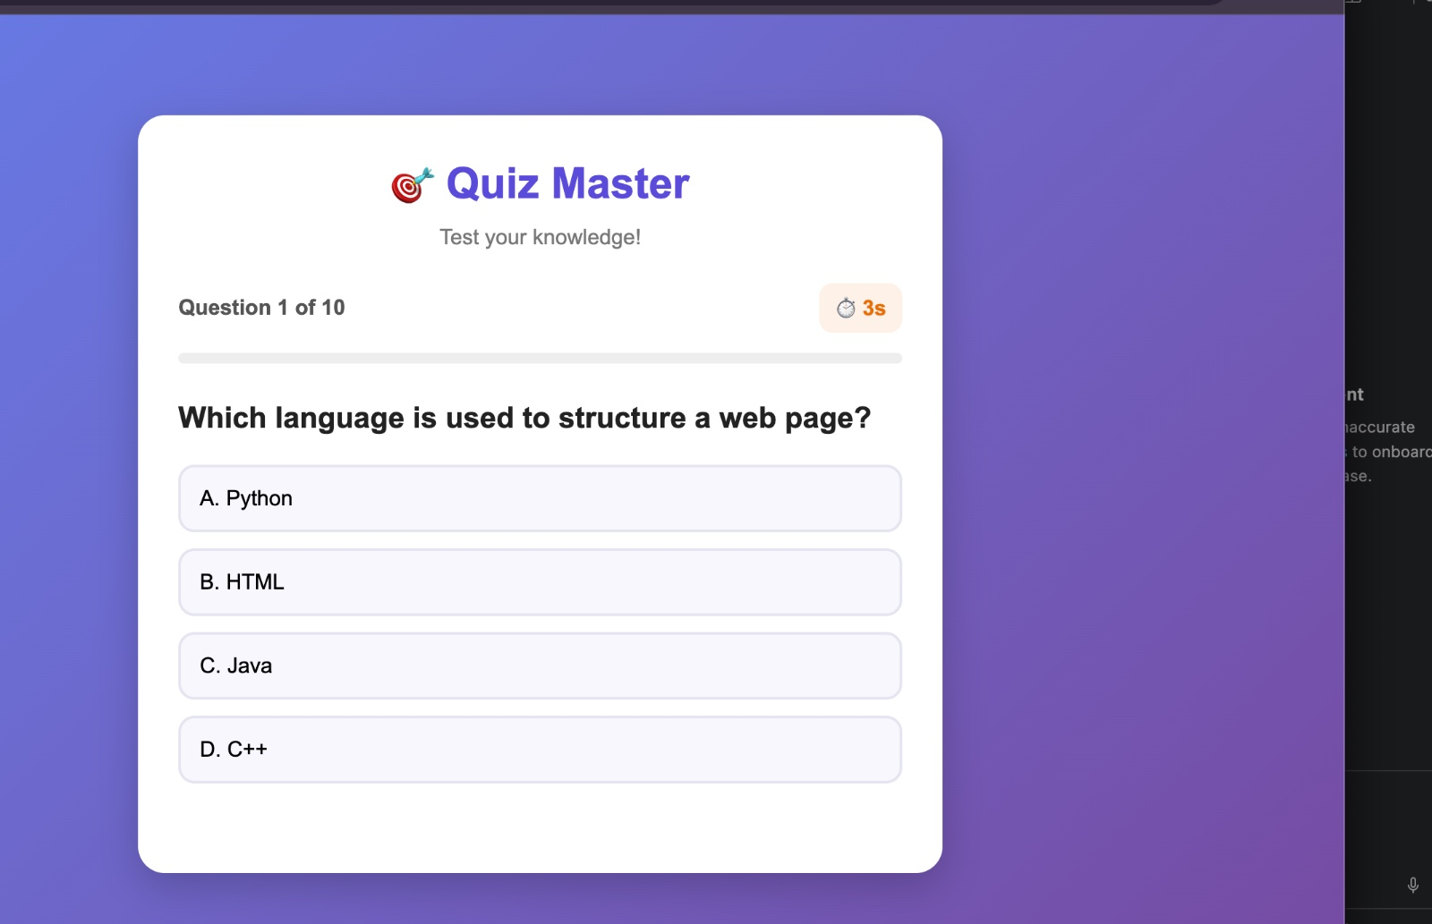

Question 1, correct answer
After choosing B. HTML, the option turns green, the other options are disabled, the feedback reads Correct answer!, and the Next Question button is enabled. The answer was checked by the Verilog simulation.
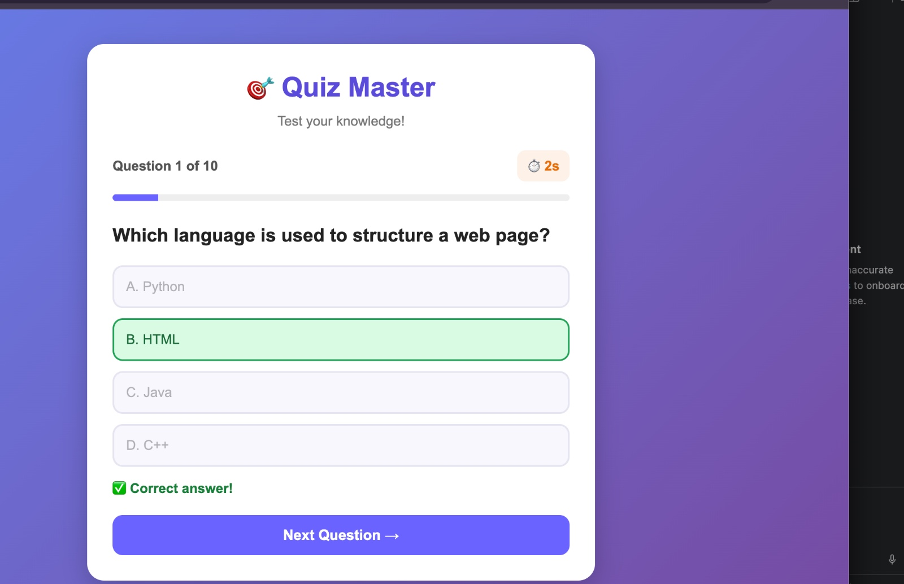

Question 3, unanswered
The third question, What does CPU stand for?, shown with all four options enabled and the timer running.
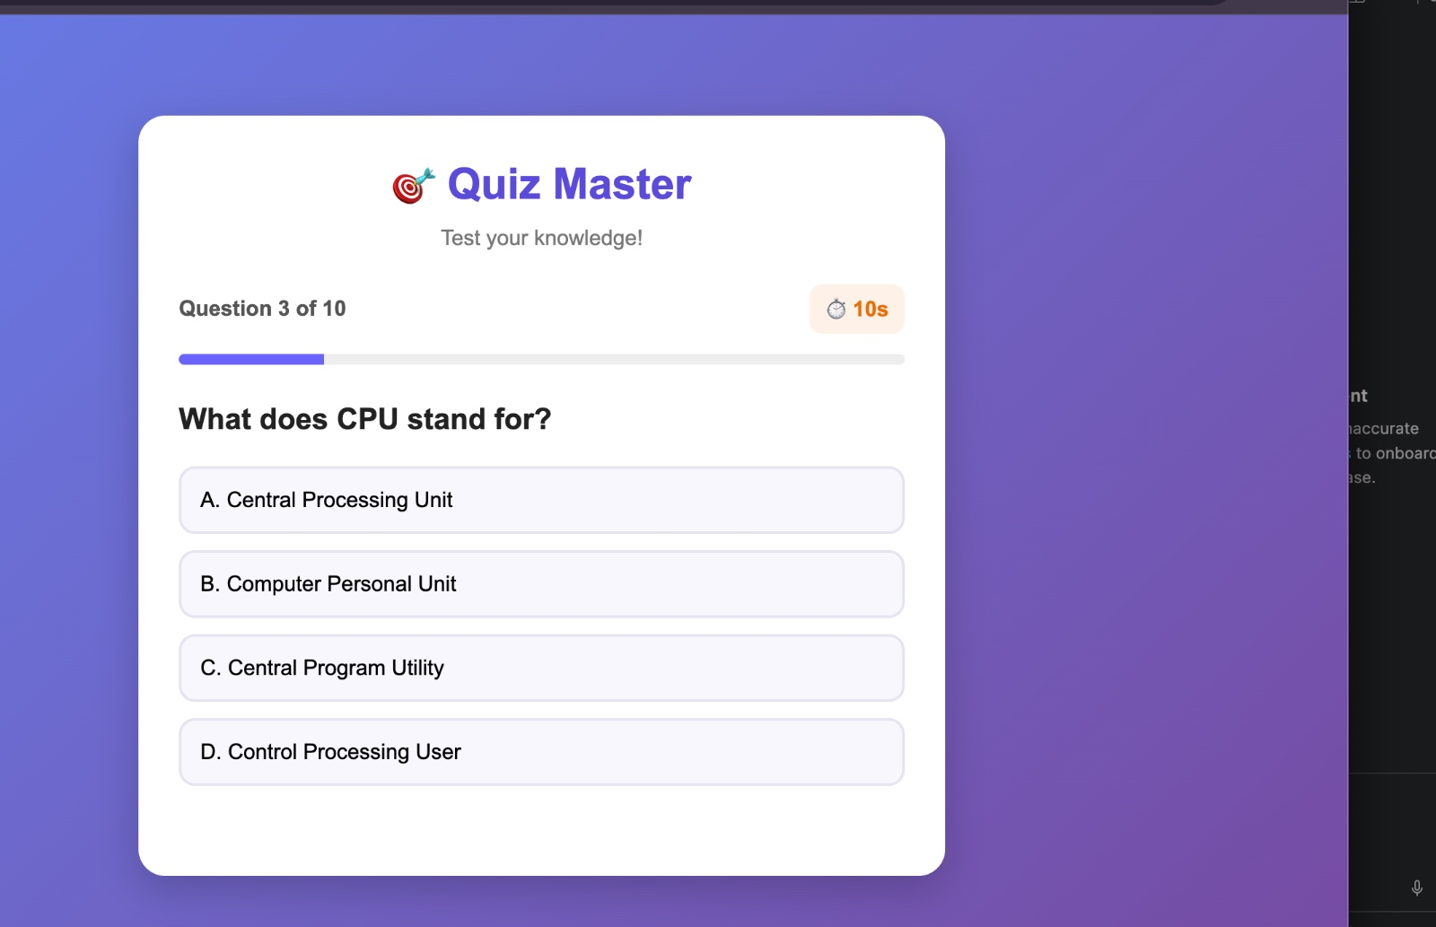

Question 3, wrong answer
After choosing B. Computer Personal Unit, that option turns red and the feedback reads Incorrect! The correct answer is highlighted. The correct option, A. Central Processing Unit, is shown in green.
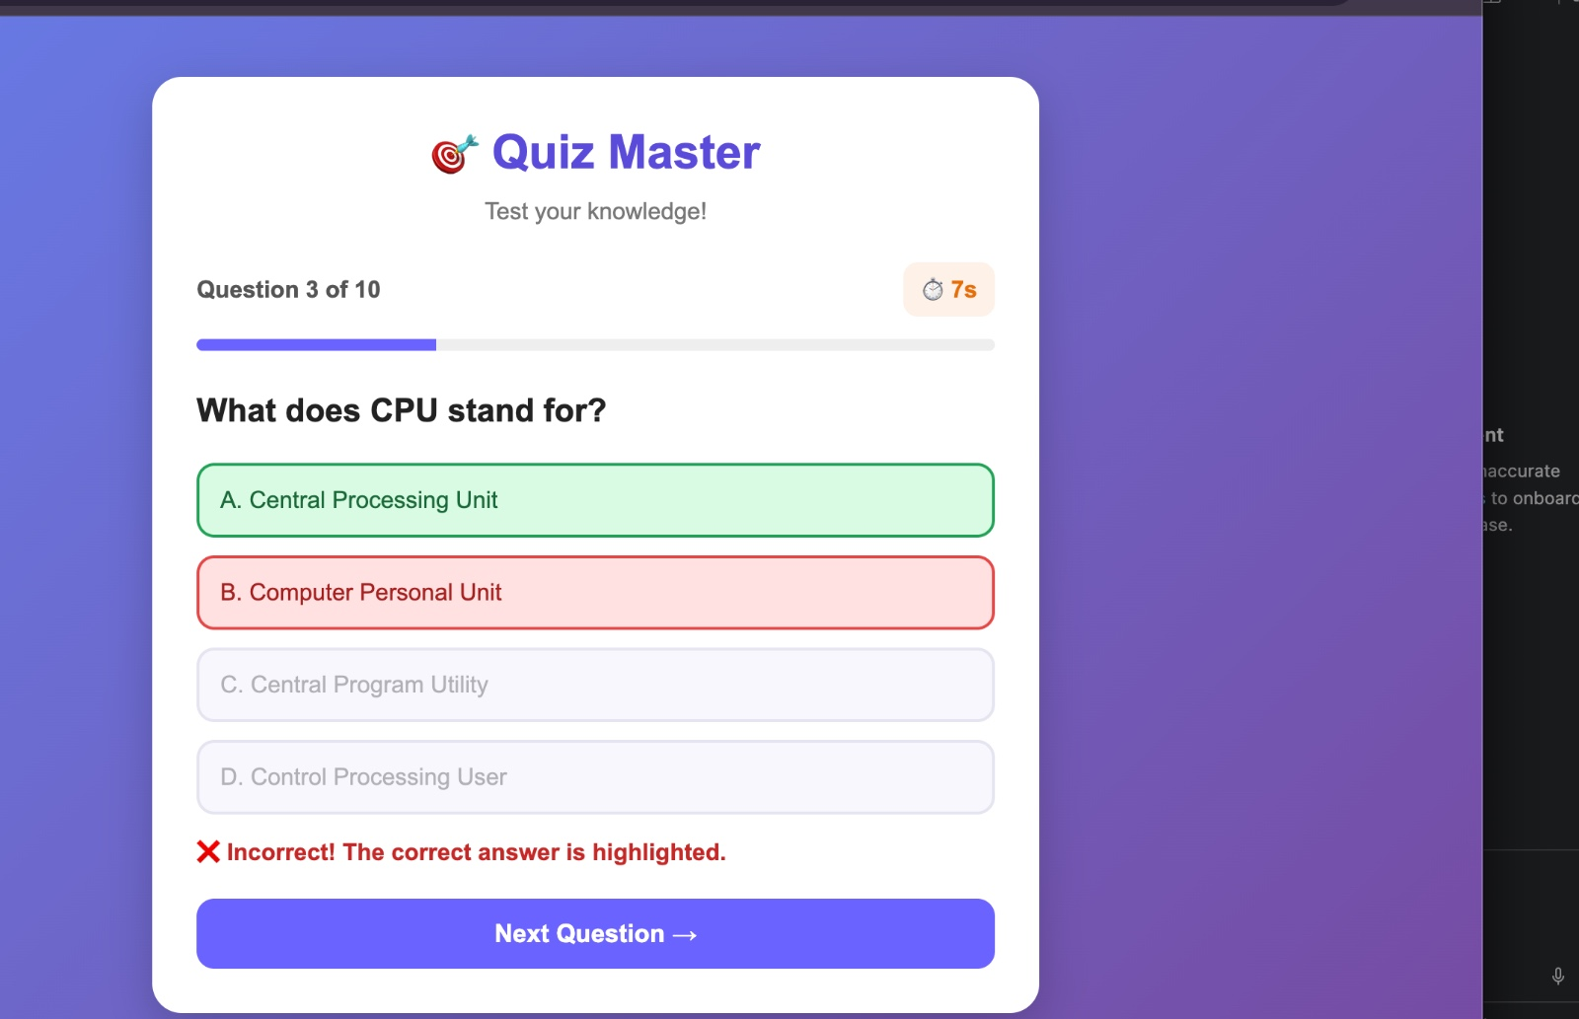

Differences between the screenshots and the uploaded code
The screenshots do not exactly match the uploaded index.html and app.py, so they appear to come from a different or newer version of the quiz. The documentation above describes the uploaded files. The differences are:
Item | Screenshots | Uploaded code
Page title | Quiz Master, with a target emoji | Quiz Application
Progress | A filled progress bar under the question counter | Text only (Question N of 10)
Score | Not visible | Score: N next to the question counter
Timer | Shown with a stopwatch icon in a rounded badge | Plain text Time left: N s
Question 3 | What does CPU stand for? | Which data type stores True or False?
Wrong answer | Feedback Incorrect! The correct answer is highlighted. and the correct option turns green | Feedback Incorrect answer!, and only the chosen option turns red
Correct answer | Feedback Correct answer! with a check mark | Feedback Correct answer!
Showing the correct option after a wrong answer would need /check to return the correct option number as well, which the uploaded app.py does not do. If you upload the newer versions of the files, I can update this document to match them.

